Launch of “DIKSHA – VIDYA DAAN” Program
Vidya Daan, a program based on donation of e-content by teachers, is an initiative by CBSE based on Sourcing of content from teachers and meant to synergize countrywide developments by providing schools and teachers from the Metro cities to the smallest villages with good quality e-content.
We feel immense pleasure to announce that due to the enthusiastic approach of Bhavan’s Mehta Vidyalaya, our school was selected among 10 schools from all over India for piloting the CBSE project.
Our principal Dr. Mrs. Anju Tandon received a letter of appreciation from CBSE acknowledging the school’s contribution.
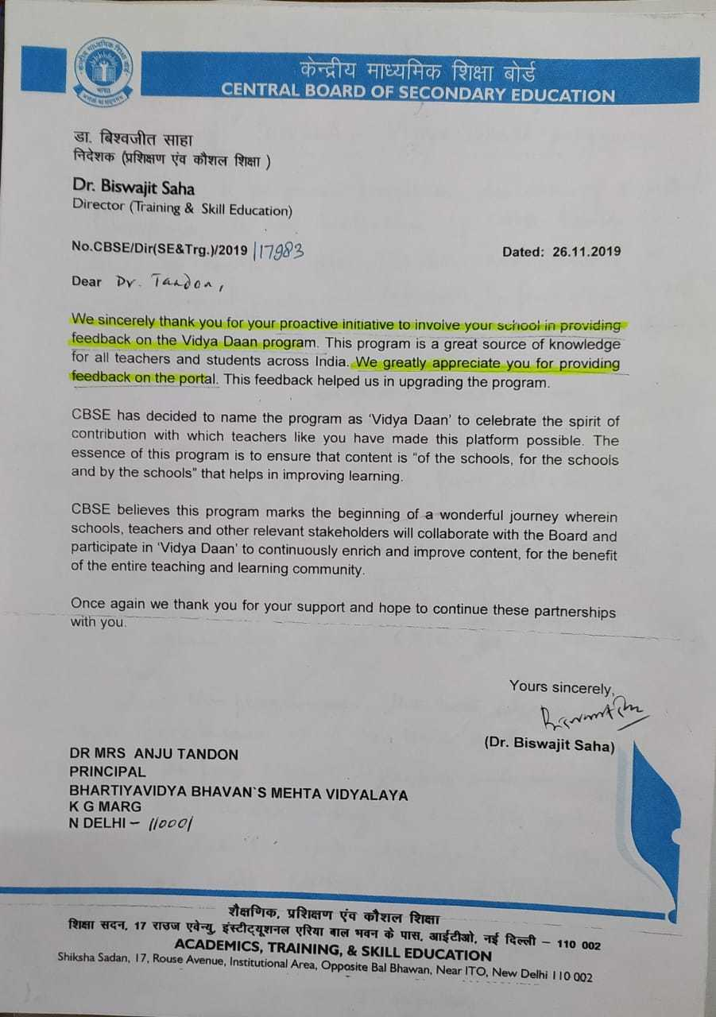
Under this programme, the best curated content for classes VI - X has been systematically organized as per NCERT syllabus which will enable better understanding of concepts by the students. All parents are henceforth required to install ‘ DIKSHA app’ and ‘SHIKSHA VANI- podcast’ launched by CBSE.
These are available on Play Store for Android phone users.

