SKYPE SESSION

To provide an international platform to the students of Bharatiya Vidya Bhavan and to give them a chance to learn a lot about different countries, International Exchange Programs have been initiated.

So keeping all this in mind and to promote it further, Skype Session was conducted on 12th of May 2017 where the selected students of middle school interacted with the students of Launceston Church Grammar School, Australia.
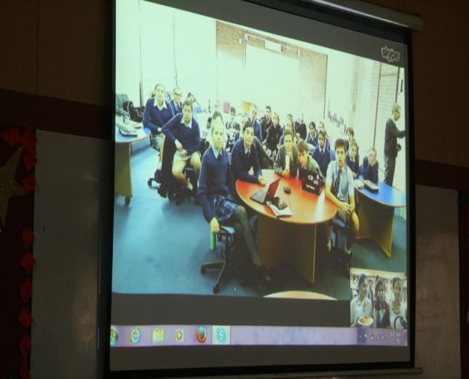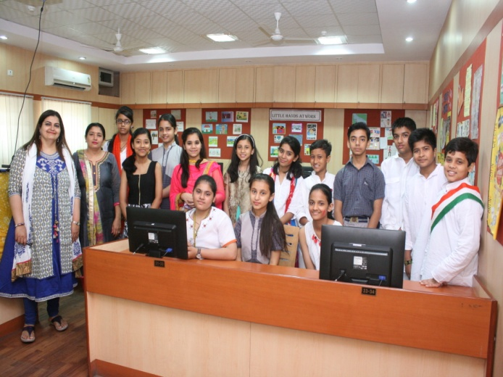
During the Skype Session students from each country took turn to introduce them and then shared their views on some important festivals of their respective countries such as Independence Day, Republic Day,Diwali,holi,Anzac Day, Dark Mofo,Australian Day.
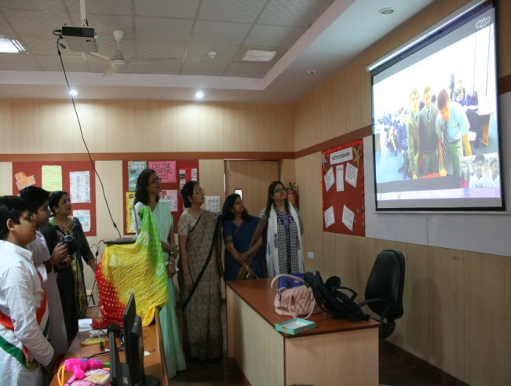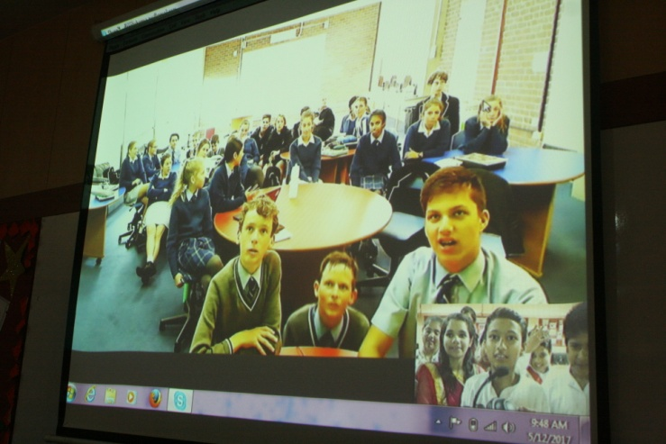
They also exchanged their view on cricket and their favourite cricket players such as Sachin Tendulkar, Ricky Pointing who happens to be the Alumni of that school.
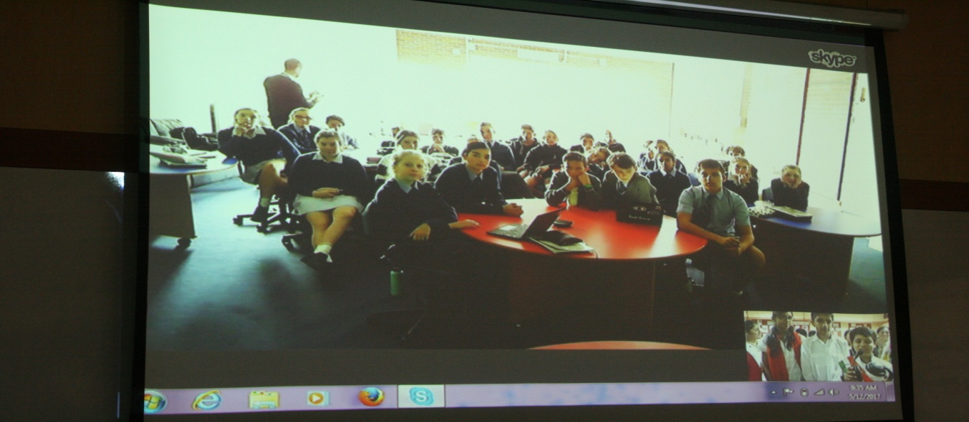
They also discussed about their school, subjects, teachers, and how they commute to school everyday.
Overall it was an interactive session and the students really had a wonderful experience.
Now my students are looking forward to our next Skype Session scheduled in the month of August.
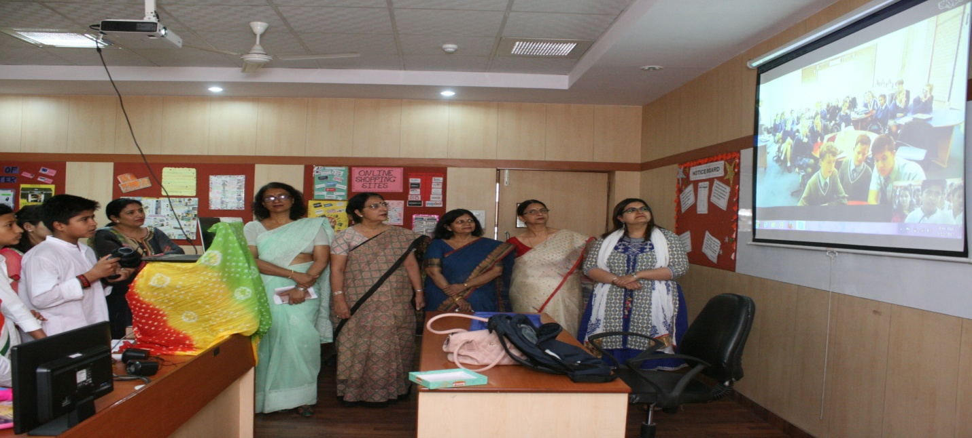
In fact we have more Skype Session planned with two more Australian Schools during this year.
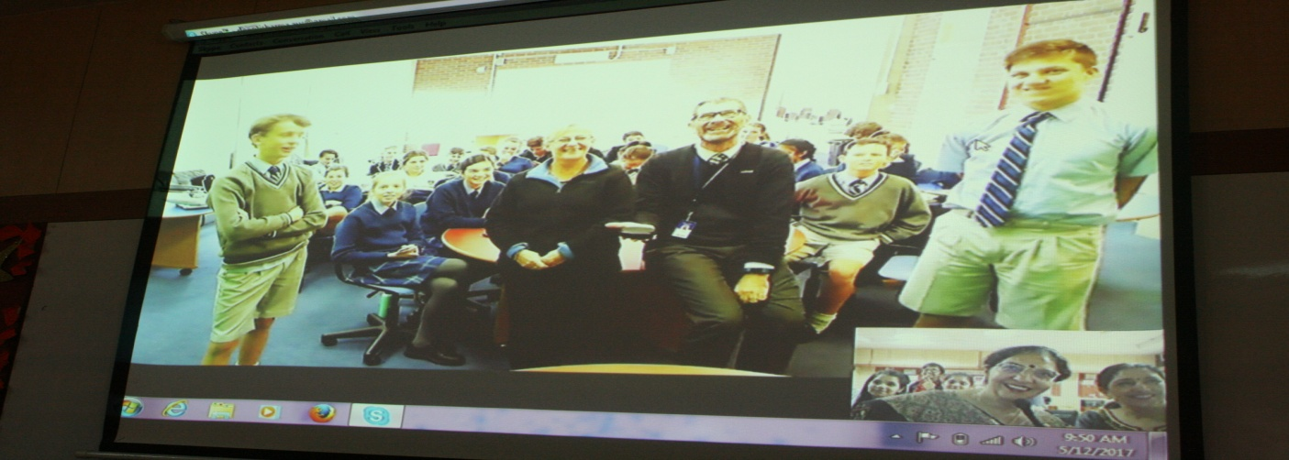
Principal Dr. Anju Tandon,Vice Principal Mrs. Vibha Kohli,Head Mistress Mrs Shashi Bhargava encouraged the students with their presence and appreciated the efforts put in by all of them.
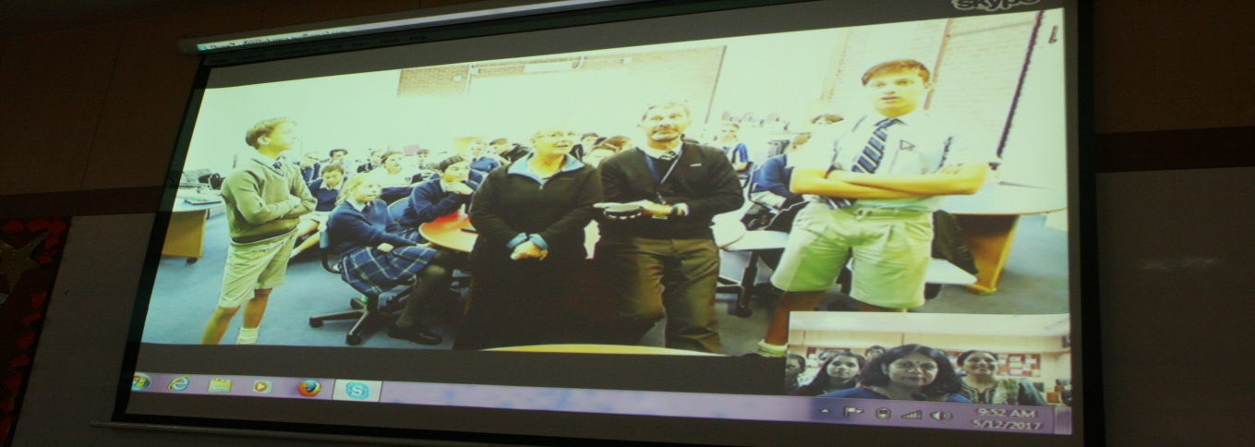
It was a well organized session conducted under the guidance of Ms Deepti Sharma and Ms Parinita Sengupta .

